**IAM-TASK**

1. Create one IAM user and assign ec2,s3 full access role.

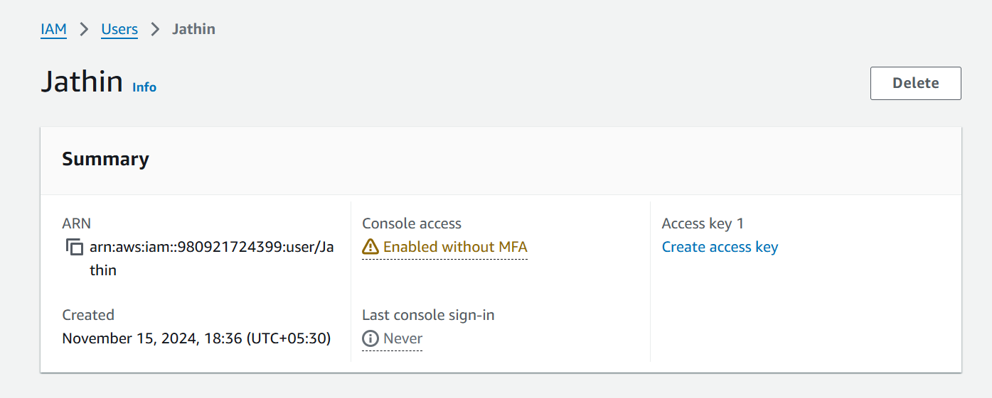

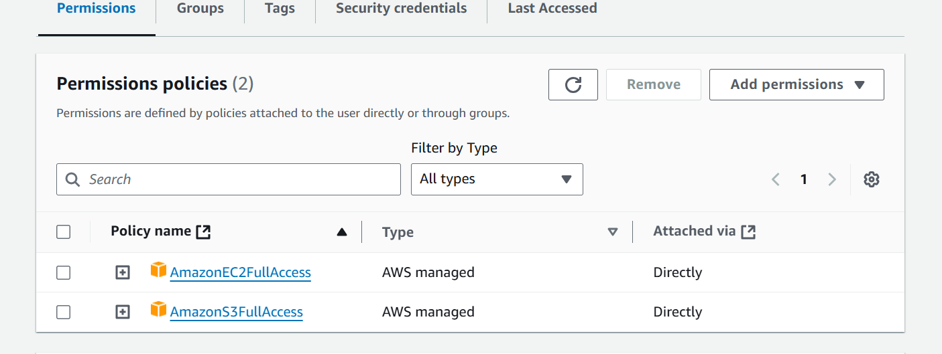

1. Create one Group in IAM and Assign Read access for ec2.

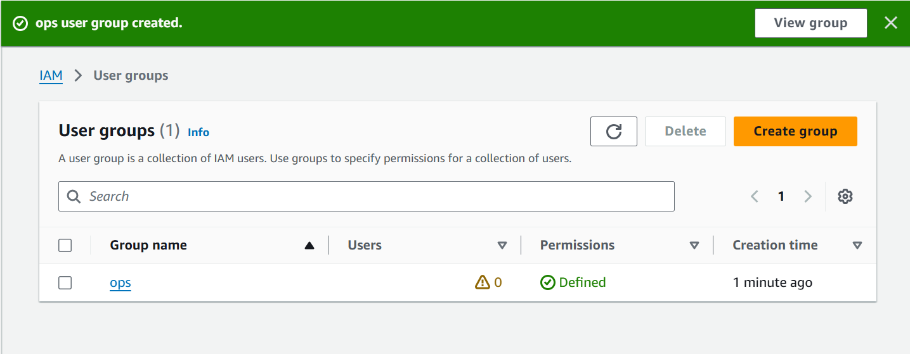

1. Create a new user with name Devops and add to the group created in task2.

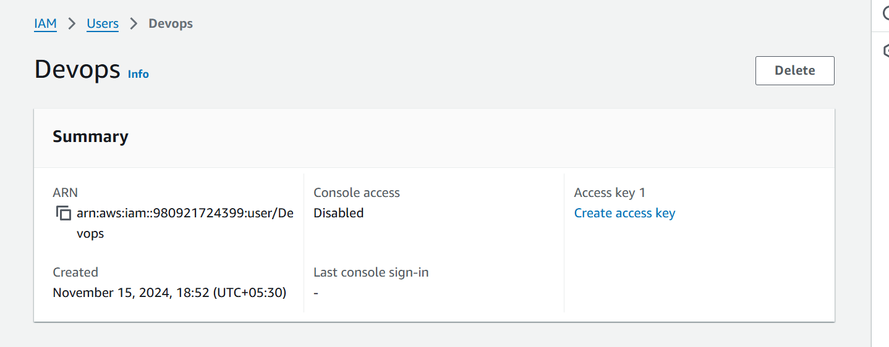

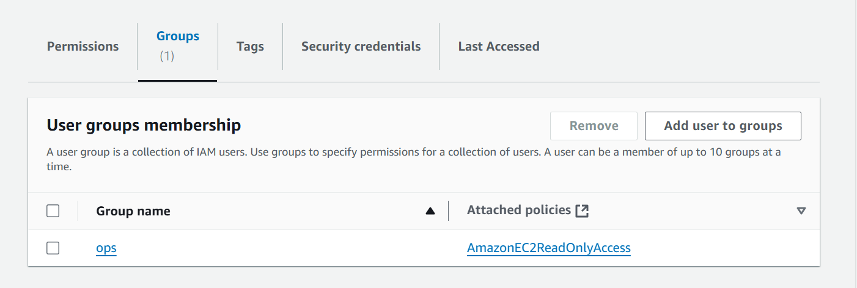

1. Write a bash script to create a IAM user with VPC full access.

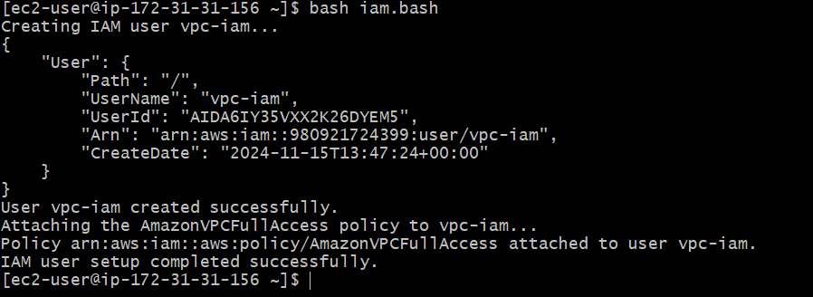

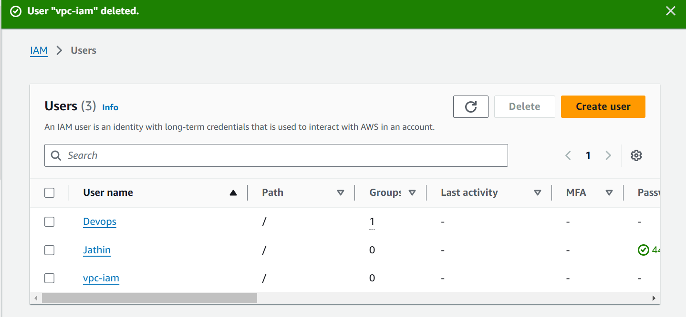

1. Create a IAM policy to access ec2 for a specific user in specific regions only.

